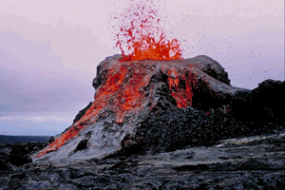
Classifying Igneous Rocks

Use p.281 of the Pearson Science Text to answer the following:

1. Why is the current position of an igneous rock not enough to classify it as intrusive or extrusive?
_____________________________________________________________________________________________________

_____________________________________________________________________________________________________

_____________________________________________________________________________________________________

2. What does texture mean when referring to rocks? ___________________________________________

_____________________________________________________________________________________________________

_____________________________________________________________________________________________________

3. Describe how colour is linked to the minerals the rock contains ___________________________

_____________________________________________________________________________________________________

_____________________________________________________________________________________________________

_____________________________________________________________________________________________________

_____________________________________________________________________________________________________

_____________________________________________________________________________________________________

4. Compare extrusive igneous rocks with intrusive igneous rocks.

 | EXTRUSIVE | INTRUSIVE
Where do they for form?

Crystal size

Speed of cooling

 | EXTRUSIVE | INTRUSIVE
Can they contain gas bubble spaces

Examples

Uses

5. Write a short paragraph comparing the two types of igneous rocks.

_____________________________________________________________________________________________________

_____________________________________________________________________________________________________

_____________________________________________________________________________________________________

_____________________________________________________________________________________________________

_____________________________________________________________________________________________________

_____________________________________________________________________________________________________

_____________________________________________________________________________________________________



